Category
EZMol: An easy-to-use protein visualisation server
Christopher Reynolds and Michael J. E. Sternberg*
¹Department of Biochemistry, School of Life Sciences, John Maynard Smith Building, University of Sussex, Falmer, Brighton, BN1 9QG, UK.
Received on XXXXX; revised on XXXXX; accepted on XXXXX

Associate Editor: XXXXXXX

abstract
Summary: EZMol is a free-to-use web server in the form of a software wizard. It is designed for the quick and easy display, manipulation and rendering of protein molecules, and is intended for users who need to quickly produce publication-quality images of protein molecules, but do not have the time or inclination to use (or learn to use) a software molecular visualisation system. EZMol allows the upload of molecular structure files in PDB format. A web page is generated including a representation of the structure in a 3Dmol.js molecular viewer that the user can manipulate. EZMol provides intuitive options for chain display, adjusting the colour/transparency of residues, adding side chains, generating a protein surface, adjusting the colour/transparency of the surface and adding labels to residues. The final adjusted protein can then be rendered to provide a high-resolution publication-quality image.
Availability: http://
Contact: s.jones@sussex.ac.uk

introduction

Existing serivicves include DeepView - Swiss-PdbViewer: http://spdbv.vital-it.ch/ & POLYVIEW-3D: http://polyview.cchmc.org/polyview3d.html
List of services at: http://molbiol-tools.ca/Protein_tertiary_structure.htm
List of services at: https://www.umass.edu/microbio/rasmol/othersof.htm
List of services at: http://en.bio-soft.net/3d.html
List of services at: http://www.rcsb.org/pdb/static.do?p=software/software_links/molecular_graphics.html

Used for the Phyre2(Kelley et al., 2015) web portal.

The dissociation experiments of Svedberg (1929) (Svedberg and Fåhraeus, 1926) established the existence of multimeric proteins – proteins built from subunits. Each subunit is a folded polypeptide chain, and these chains assemble with non-covalent interactions to form a structure made up of multiple subunits. The multimeric structure of proteins is now referred to as the quaternary structure. Interactions play a part whenever subunits work together in a protein, or whenever proteins work together, or influence each other. Subunits are composed of multiple structural domains. Domains were first described by Wetlaufer (1973) who noticed autonomously folding distinct structural regions in polypeptide chains, which folded autonomously during the early stages of tertiary structure formation. Domains are now known to be units of function and evolution as well (Doolittle, 1995).
Protein interactions occur because of the gain in free energy which occurs due to geometrical and physicochemical interactions between the two subunits at the interface. The potential free energy gain, also known as solvent-mediated potential, is determined by the strength of the interactions, and indicates the stability of the interface. Protein-protein interaction can be regulated/mediated by conditions in the protein environment: decreasing with extremes of temperature and pH (Deng et al., 1976), decreasing with increasing ionic strength (Heimburg and Marsh, 1995), or regulated/mediated by other proteins (Markus and Benezra, 1999) (Klemm et al., 1998).
There are several different parameters that are involved in contributing to the increase in free energy produced by protein-protein binding. As well as the contribution of size and shape, alanine-scanning mutagenesis (Clackson and Wells, 1995) has been used to see which residues contribute the most towards stability. This method has found that most binding energy comes from a few specific residues termed hotspots (Moreira et al., 2007). Ma et al. (2003) found that residues involved in polar hotspots were structurally conserved. Studies have also shown that the presence of bridging water molecules (Furukawa and Morishima, 2001), salt bridges (Furukawa et al., 2002), and hydrophobic interactions. (Chothia and Janin, 1975) (Furukawa et al., 2002), all contribute to the binding energy and subsequent stability of the protein-protein interactions.
The server created in this project is based on the UCL server (Jones and Thornton, 1995) (Luscombe et al., 1998), but is intended to be more robust, and incorporate some extra analyses of the protein interface. Also the new server will provide a facility to automatically retrieve and analyse structural data from the PDB on the submission of a PDB entry code. Multiple PDB entry codes should be able to be submitted for batch analysis of interfaces, so that large data sets can be retrieved without submitting each PDB file for individual analysis. It is also intended that this server should provide some sort of statistical similarity test to attempt to automatically recognise classes of interfaces, by matching them against a large database of pre-analysed interface data divided into interface classes. The server developed in this project will calculate a set of values for interface characteristics for a given protein-protein interface. The calculated values will be based on the ones already calculated by the UCL Protein-Protein Interaction Server (Jones and Thornton, 1995) (Luscombe et al., 1998). Users will be able to submit a PDB file of their own for analysis as they already can with the UCL server, or they will be able to enter multiple PDB entry codes and the server will retrieve the required PDB files from the PDB database, perform an analysis on them, and e-mail the results to the user.

methods
The PROTORP web server was designed to be as intuitive and helpful as possible. The page uses JavaScript to enable and disable text boxes on the front page as appropriate and to check that an appropriate number of fields have been filled in and with valid data.
The user can select from three methods to input data on the main page: (1) browse for a PDB coordinate file on the hard drive, (2) enter a delimited list of PDB codes directly onto the webpage, or (3) browse for a file on the hard drive containing a delimited list of PDB codes. The user must enter two single-letter chain identifiers, denoting the letter-codes of the two subunits to analyse the interface between. The user is also required to enter a title for the analysis and their e-mail address. The results will be calculated, and a link to a page containing links to all the results will be e-mailed to them.
Figure 1. Close-up screenshot of the data entry form showing the fields the user should fill in. The chain identifier fields are disabled here because the user has selected to give a list of PDB files. They only become enabled if the user opts to browse for a PDB coordinate set.

The server first validates the submitted PDB file; where a PDB file contains multiple models of the same protein, only the first model is written to the new file.
When the user views the results, the parameters for each interface are displayed on a different web-page, for ease of reading, and comprehension by the user. An option to download all the results as a single text file has been included and can be downloaded from the page the user is directed to after submitting a request. The text file is in the format of a table, with a column for the PDB code, a column for the chain identifiers of each of the two chains between which the interface is being examined, and a column for each of the parameters returned by the PROTORP program.
In order to determine the atoms and residues that made up the interface and what their contribution to the interface is, the NACCESS program (Hubbard and Thornton, 1993) [http://wolf.bms.umist.ac.uk/naccess/] was used. NACCESS determines the accessibility of each atom and residue to the surrounding solvent. To do this, NACCESS uses a method devised by Lee and Richards (1971) and developed by Hubbard (1992), where spheres with radii corresponding to the extent of Van der Waal’s forces are assigned to each atom or group of atoms using van der Waal radii values calculated by Chothia (1976).
The default value is 0.05 Å, which is used by the PROTORP server for the accessibility calculations. NACCESS ignores heteroatoms, hydrogen atoms, and waters. For this study, the radius of the probe solvent molecule has been left at the default setting of 1.4 ångströms. Convexity will produce a higher than normal value for the interface, while concavity will produce a lower than normal value for the interface, although this effect is decreased with a smaller probe.
Atoms and residues were only considered to be involved in the interface if they had a difference in accessible surface area of at least 1.0 ångströms².
Because of the folding of the polypeptide chain, interface residues that form a contiguous patch on the surface of the protein structure may be spread out across the polypeptide sequence. This parameter gives the number of amino acid residue segments present in the interface patch. Segments are defined as separate if they are separated by more than 5 amino acid residues.
The gap volume is used to give a measure of the complementarity and closeness of packing of the interface between the two subunits, by measuring the volume of empty space between the atoms. The gap volume is determined using the program SURFNET (Laskowski, 1995).
The planarity, length, and breadth are calculated by measuring the root-mean-squared distance (RMS) of the horizontal, vertical, and normal components of all the three-dimensional atomic coordinates from the centre of gravity of all the atoms with respect to a best-fit plane through the atoms. In order to calculate the above three values, PRINCIP, part of the SURFNET package (Laskowski, 1995), is used to perform principal component analysis on the three-dimensional co-ordinates of the atoms in the interface.
Eccentricity is a property of all ellipses, first noted by Apollonius of Perga (c. 200 BCE), and is a measure of how much the ellipse deviates from being perfectly circular. It has no units.
The atoms are classified as polar, non-polar, or neutral, using the classification described by Warme and Morgan (1978). The total contribution to the interface accessibility from each class of atom is derived from the ASA data produced by NACCESS.
Amino acids can be classified into groups according to the overall atomic composition. In this study, the amino acids in the interface are classified as hydrophobic, polar, or charged, according to the table below. The classifications are the same as in the Jones and Thornton (1995) study.
The DSSP program [http://swift.cmbi.ru.nl/gv/dssp/] designed by Kabsch and Sander (1983) was used to classify the secondary structures in the interface. residues are classified as being part of either α-helices or β-strands and sheets, and the server also defines the overall secondary structure of the interface based on these calculated percentage distributions of secondary structure, using the definitions proposed by Jones and Thornton (1995).
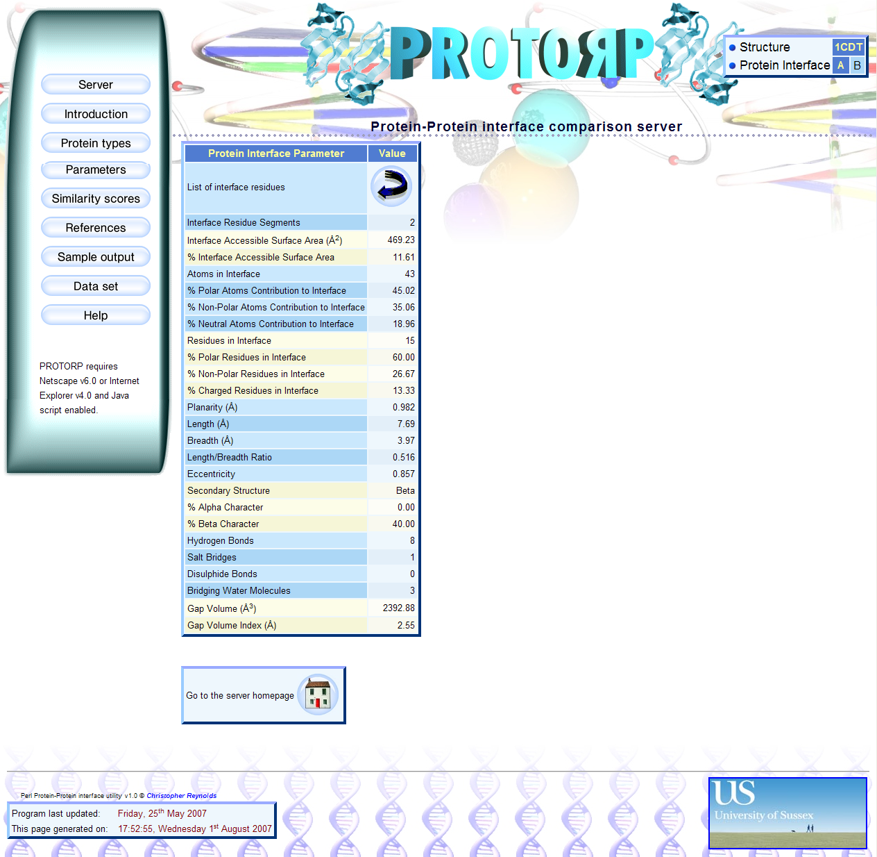
Figure 2. Screenshot showing a sample results page from the PROTORP server, showing parameter data for a sample PDB entry.

The program HBPLUS (McDonald and Thornton, 1994) [http://www.biochem.ucl.ac.uk/bsm/hbplus/home.html] is utilised to determine occurrences of hydrogen bonds in the protein. This is used to count all the hydrogen bonds involved in the interface and the bridging water molecules (water molecules that have at least one hydrogen bond to each of the subunits).
To find the salt bridges in the interface, the program searches through the atoms in the interface and classes as salt bridges all oppositely charged ion pairs that have a distance between them of no more than 4.0 ångströms
To find the disulphide bonds in the interface, the program searches through the atoms in the interface and classes as disulphide bonds all oppositely charged ion-pairs that have a distance between them of no more than 3.0 ångströms.

acknowledgements
David Damerell for help in interfacing MySQL with Perl and installing PERL modules, the University of Sussex for providing the equipment and resources used in this project, Guy Gray who produced some of the graphic art featured on the website, and the hundreds of researchers who determined the structures of the proteins in the PDB database, without the work of whom, this project would never have been possible in the first place.

Conflict of interest: none declared.

References
Kelley, L.A., Mezulis, S., Yates, C.M., Wass, M.N., Sternberg, M.J.E., 2015. The Phyre2 web portal for protein modeling, prediction and analysis. Nat Protoc. 10, 845–858.

*To whom correspondence should be addressed.

